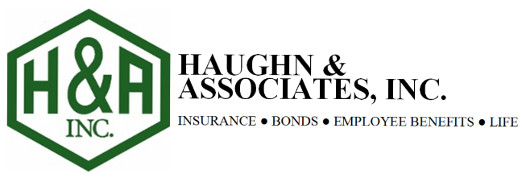

Helping you keep more of what you make – Self Insured Plans

The Situation:
Client: The Company is an industry leader of paving and commercial roofing. Their services help builders and developers’ efficiently and cost effectively complete a wide range of projects including; new construction, asphalt maintenance, roller compacted concrete, new roof construction, roof replacement, roof maintenance, residential and commercial developments, and parking lots.
Needs: Strategies to reduce cost on their $802,000 + annual premium group medical plan.
Plan: Fully Insured PPO

Analysis:
Company is a closely held business that has over 130 employees and is working hard to thrive in the turbulent economy. The rising cost of insurance specifically group medical had been a source of concern for the owners. While providing benefits was important, the annual 15%+ rate increases were putting pressure on the bottom line. To no avail, they had tried conventional strategies such as; reducing benefits and shifting cost to the employees
After a review of the plan data and agreement from the employer to implement a self-funded plan, Haughn & Associates was able to negotiate stop loss that would allow the employer to self-fund their benefits without exposing themselves to catastrophic risk. By setting up a self-insured plan, the owner would have the opportunity to reclaim some of the dollars between the premiums funded and the actual claims paid out.
Result:
In addition to capturing carrier underwriting profit, Haughn & Associates was able to help drive additional savings for the company. With access to transparent claim data we were able to help the employer strategically implement programs to help employees better manage their health and save money for them and the company. While many employers continue to face double digit increases in the traditional market, the company has reduced medical plan cost 22%.
First year premium savings $164,716.14 including runout claims, Final attachment point $536,662.00 or 75.92%. Fixed cost $214,508.00 and claim costs $407,456.31, Total cost $621,964.31. Fully insured costs $802,000. Run out claims totaled $15,319.55 and reduced maximum self-funded claim liability $536,662.00.

